Safe Work Practice

Drills

How do you select the proper bit or attachment?
  - Follow manufacturers' instructions when selecting and using a bit or attachment, especially with unfamiliar drills or work.
  - Select the bit or attachment suitable for the size of the drill and the work being done.
  - Ensure that the bit or attachments are properly seated and tightened in the chuck.
  - Use only bits and attachments that turn true.
  - Use the auxiliary (second) handle for larger work or continuous operation.

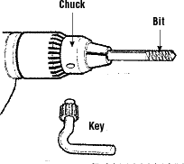

What should you do when working with powered hand drills?
  - Wear safety glasses or a face shield (with safety glasses or goggles).
  - Keep drill air vents clear to maintain adequate ventilation.
  - Keep drill bits sharp always.
  - Keep all cords clear of the cutting area during use. Inspect for frays or damage before each use.
  - Disconnect power supply before changing or adjusting bit or attachments.
  - Tighten the chuck securely. Remove chuck key before starting drill.
  - Secure work piece being drilled to prevent movement.

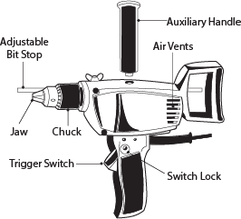

  - Slow the rate of feed just before breaking through the surface.
  - Drill a small "pilot" hole before drilling large holes.

What should you do when working with small pieces?
  - Clamp stock so work will not twist or spin.
  - Do not drill with one hand while holding the material with the other.

What should you avoid when working with powered hand drills?
  - Do not use a bent drill bit.
  - Do not exceed the manufacturer's recommended maximum drilling capacities.
  - Do not use a hole saw cutter without the pilot drill.
  - Do not use high speed steel (HSS) bits without cooling or using lubrication.
  - Do not attempt to free a jammed bit by starting and stopping the drill. Unplug the drill and then remove the bit from the work piece.
  - Do not reach under or around stock being drilled.
  - Do not overreach. Always keep proper footing and balance.
  - Do not raise or lower the drill by its power cord.
  - Do not use in wet or muddy locations. Use a nonpowered drill instead.
  - Do not use excessive force to drill into hard material. Reduce drill speed if possible.

